Project Review: Kinematics Pick and Place

1. From the kr201.urdf. xacro, we can get the DH parameters of the kuka arm and the pose of the robot when all the joint variables are equal to zero. The arm is referenced in the xz frame. The no. of joints in arm are numbered from 1 to 6 and the no of links are numbered from 0-6.
2. The values we get from the file are alpha0-6, a0-6, d1-7
3. Ai-1 is the distance from zi-1 to zi measured along xi-1 axis.
4. Di is the distance between xi-1 and xi measured along the zi axis.
5. the twist angle alpha is the angle between zi-1 and zi measured about the xi-1 axis according to the right-hand rule.

From the URDF file described above, the joint location and the types of joints are given.

S = { alpha0: 0,a0: 0, d1: 0.75,q1: q1,

alpha1: -pi/2, a1: 0.35, d2: 0, q2: -pi/2+q2,

alpha2: 0, a2: 1.25, d3: 0,

alpha3: -pi/2, a3: -0.054, d4: 1.50,

alpha4: pi/2, a4: 0, d5: 0,

alpha5: -pi/2, a5: 0, d6: 0,

alpha6: 0, a6: 0, d7: 0.303, q7: 0}

These are the DH parameters derived from the URDF file as well as the arm in the zero orientation.

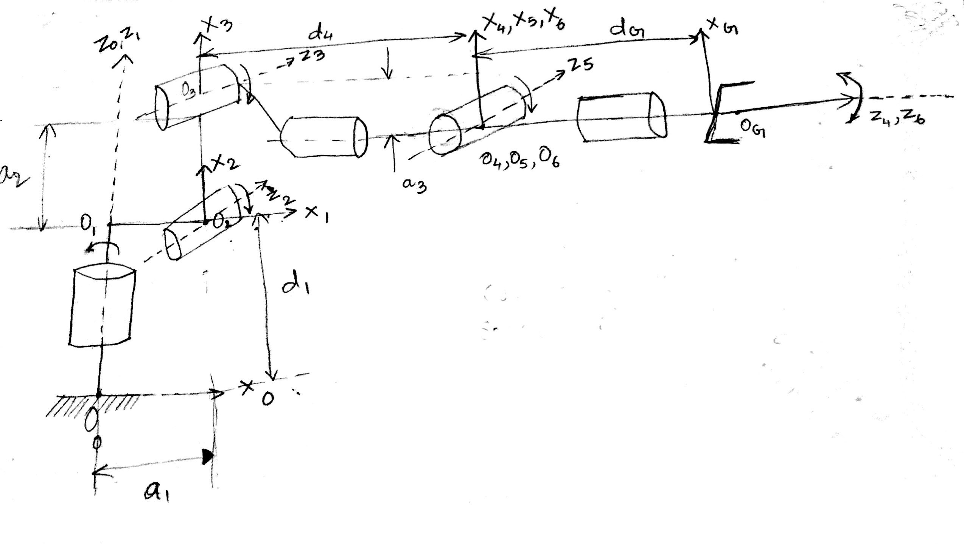

**Alpha:** If the axes are parallel, the twist angle between z axes is zero and if they are perpendicular, the angle is 90 degrees. But the direction of the angle is dependent on the right-hand rule.

**A-Value:** As we can clearly see from the URDF file, the joint origin coordinates are with respect to the previous joint origin coordinates.

1. a_0 is the distance between Z0 and Z1 and they both intersect so a_0 is zero.
2. a_1 is the distance between Z1 and Z2 which is the translation between the two coordinate systems which is 0.35
3. a_2 is the distance between Z2 and Z3 which is the translation in the direction of X-axis which is Z axis with respect to the previous joint axes reference frame which is 1.25
4. a_3 is also calculated same as the a_2 and the value is -0.054.
5. a_4, a_5 and a_6 values are 0 as the origins intersect and there is no translation.

**D-value:**

1. d1 is the distance of translation between x0 and x1 along z1 axis which is 0.33+0.42= 0.75.
2. d2, d3 values are 0
3. d4 is the distance of translation between x3 and x4 along z4 axis which is 0.96+0.54=1.5.
4. d5, d6 values are zero
5. d7 is the distance of translation between x6 and x7 along z7 axis which is 0.193+0.11 = 0.303

There is a constant offset of -90 degrees while measure theta 2 or q2. So, it is added to the q2.

3. Inverse Kinematics Problem:

Decoupling the inverse kinematic problem into Inverse position and inverse orientation.

We can get the coordinates of the wrist center i.e., the position and orientation of it.

From the gazebo environment, the end effector position and orientation are calculated which are x,y,z coordinates and the roll, pitch, yaw which are orientation of the end effector.

The Rotation matrix of the end effector is calculated by the x,y,z rotations. There is a difference in the orientation of the gripper or end effector from with respect to the joint reference frame. So, the end effector is aligned with the joint reference frames by rotating the z axis by 180 degrees and y axis by -90 degrees.

The correction is then applied to the Rotation matrix we get from the end effector orientation and then the wrist center is calculated.

Let us say x, y, z are the wrist coordinates. After the calculation of wrist center, we calculate the values of theta1, 2, 3 and explained by the figure below.

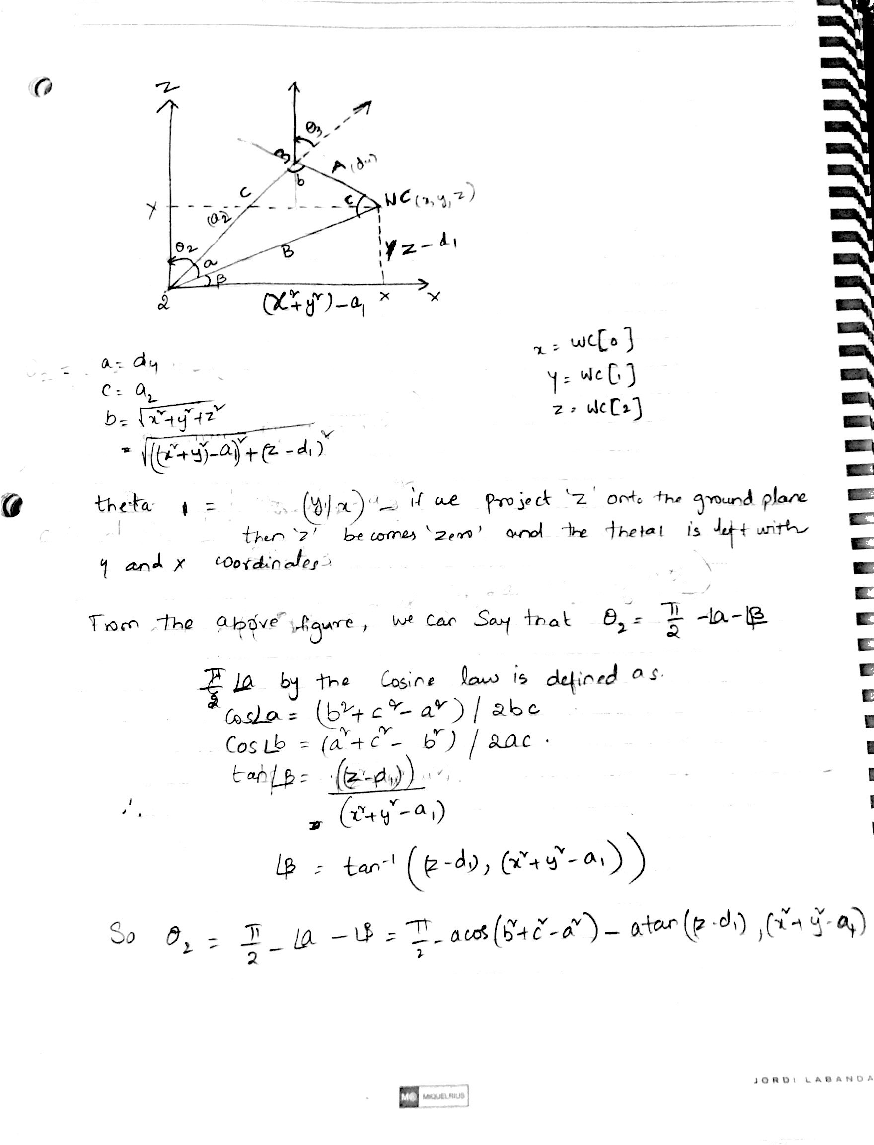

The above figure is the theoretical explanation of the calculation of the1 and theta 2 values. Theta 3 calculation is same as the theta2 which is

theta 3 = pi/2 – angle (b)

The rotation matrix from joints 3_6 are calculated from the transformation matrix 3_6 by substituting the values from the DH parameter table.

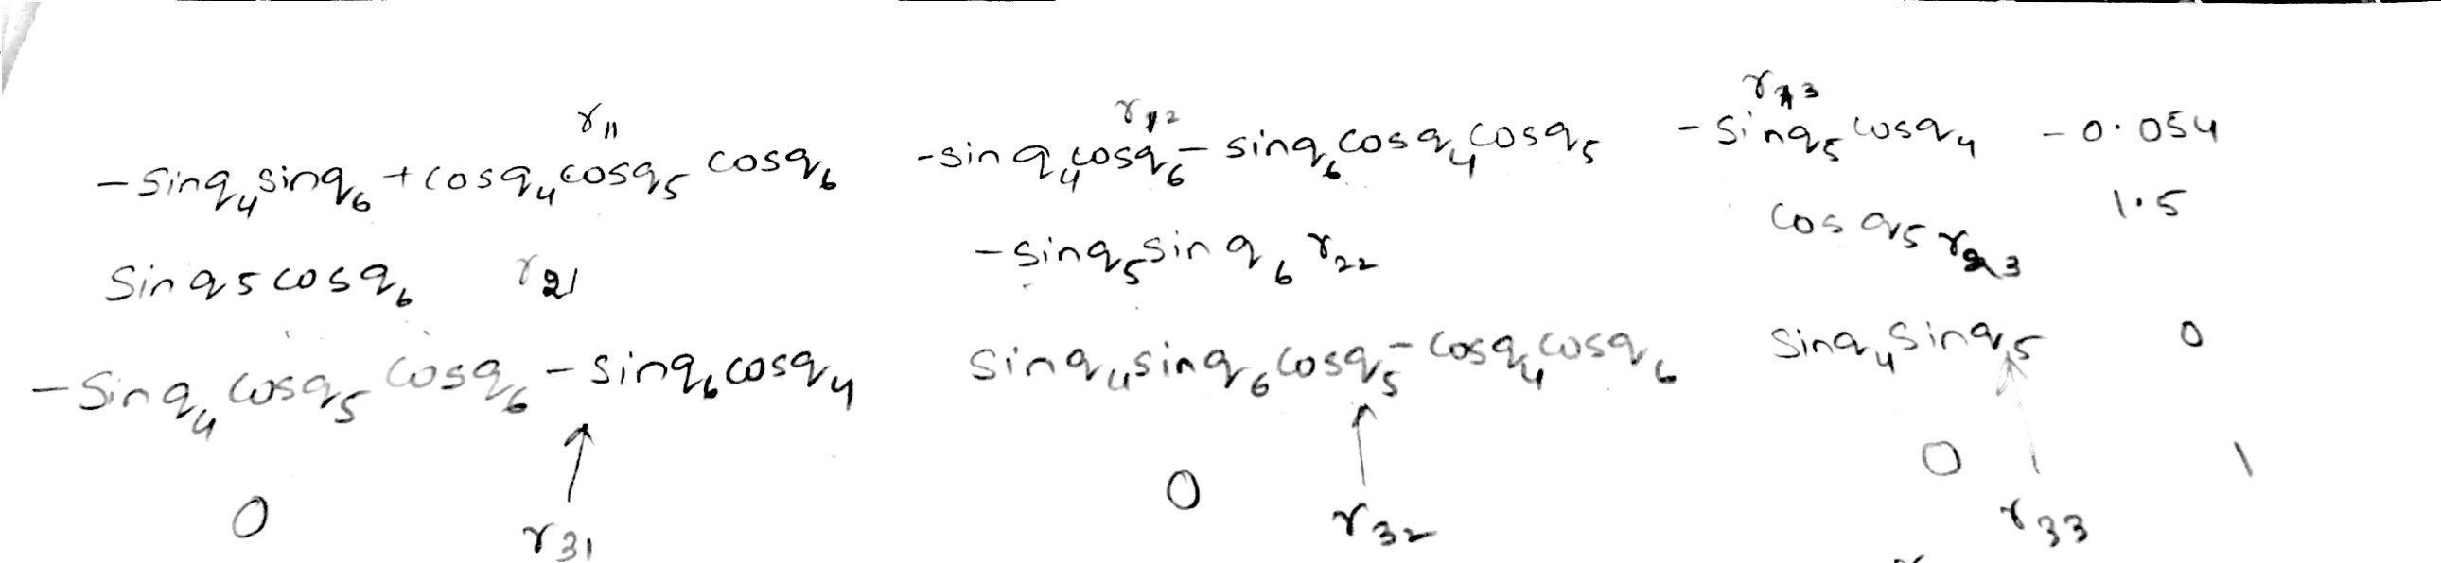

The above figure shows the transformation matrix 3_6 of which the elements of rotation matrix R3_6 are extracted.

The main point I remembered while extracting the joint angle 4,5,6 equations are they should be a tan inverse functions. The use of atan2 function in the python program while calculation would give close to accurate results.

The detailed explanation of the calculation of joint angles 4,5,6 are explained in the figure below.

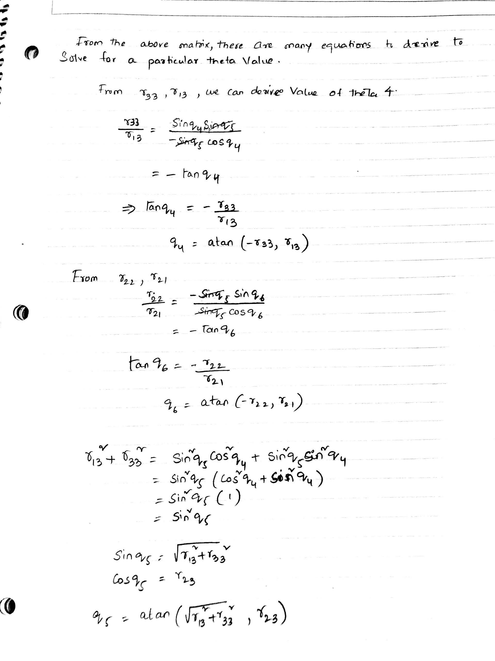

Project Implementation:

The code starts with the DH parameters symbols and the values calculated from the URDF file. Using those values the transformation matrix from joint 0 which is fixed to the joint 7 are calculated with respect to the previous joint except for joint 0.

The wrist center is calculated from the position and orientation of the end effector and from the Rotation matrix of joint0_joint3 and the Rotation matrix of the end effector are compared to the R3_6 matrix and the values of theta3_6 are calculated. The end effector is fixed to the joint 6 and the orientation of the end effector depends on the movement of the joints 4,5,6.

The file IK_server.py which I submitted could place 10/10 objects in the bin. The collection and dropping of objects are shown below.

